**Phase-3 Practice Project: Assisted Practice -**

**7.You are given a project to demonstrate RESTful with Spring Boot.**

**Source Code:**

**StudentController.java:**

**package** coms.RestfullServiceWithJPA.controllers;

**import** java.util.List;

**import** org.springframework.beans.factory.annotation.Autowired;

**import** org.springframework.http.HttpStatus;

**import** org.springframework.http.ResponseEntity;

**import** org.springframework.web.bind.annotation.DeleteMapping;

**import** org.springframework.web.bind.annotation.GetMapping;

**import** org.springframework.web.bind.annotation.PathVariable;

**import** org.springframework.web.bind.annotation.PostMapping;

**import** org.springframework.web.bind.annotation.PutMapping;

**import** org.springframework.web.bind.annotation.RequestBody;

**import** org.springframework.web.bind.annotation.RequestMapping;

**import** org.springframework.web.bind.annotation.RestController;

**import** coms.RestfullServiceWithJPA.model.Student;

**import** coms.RestfullServiceWithJPA.service.StudentService;

@RestController

@RequestMapping("/api/v1") // http://localhost:9091/api/v1/std

**public** **class** StudentController {

@Autowired

StudentService ss;

@GetMapping(value="/std")

**public** ResponseEntity<List<Student>> GetAllStdInfo()

{

**return** **new** ResponseEntity<List<Student>>(ss.ShowAll(), HttpStatus.***OK***);

}

@PostMapping(value="/std")

**public** ResponseEntity<String> NewStudent(@RequestBody Student std)

{

**if**(ss.AddStudent(std).equals("Success"))

**return** **new** ResponseEntity<String>("New Student Details are added", HttpStatus.***CREATED***);

**return** **new** ResponseEntity<String>("Error ! Student Details are not added", HttpStatus.***OK***);

}

@GetMapping(value="/std/{id}")

**public** ResponseEntity<Object> GetOneStd(@PathVariable **int** id)

{

Student std = ss.SearchStd(id);

**if**(std!=**null**)

**return** **new** ResponseEntity<Object>(std, HttpStatus.***OK***);

**return** **new** ResponseEntity<Object>("Student Not Found", HttpStatus.***NOT_FOUND***);

}

@PutMapping(value="/std/{id}")

**public** ResponseEntity<Object> ModifyStudent(@RequestBody Student std, @PathVariable **int** id)

{

Student st = ss.SearchStd(id);

**if**(st!=**null**)

{

st = std;

**if**(ss.UpdateStd(std).equals("Success"))

**return** **new** ResponseEntity<Object>("Student Modified", HttpStatus.***OK***);

}

**return** **new** ResponseEntity<Object>("Student Not Found", HttpStatus.***NOT_FOUND***);

}

@DeleteMapping(value="/std/{id}")

**public** ResponseEntity<Object> DeleteStudent(@PathVariable **int** id)

{

Student std = ss.SearchStd(id);

**if**(std!=**null**)

{

ss.DeleteStd(id);

**return** **new** ResponseEntity<Object>("Student Deleted", HttpStatus.***OK***);

}

**return** **new** ResponseEntity<Object>("Student Not Found", HttpStatus.***NOT_FOUND***);

}

}

**Student.java:**

**package** coms.RestfullServiceWithJPA.model;

**import** javax.persistence.Entity;

**import** javax.persistence.GeneratedValue;

**import** javax.persistence.Id;

**import** javax.persistence.Table;

@Entity

@Table(name="RestApi_Std")

**public** **class** Student {

@Id

@GeneratedValue

**private** **int** rollno;

**private** String sname;

**private** String course;

**private** **float** fees;

**public** **int** getRollno() {

**return** rollno;

}

**public** **void** setRollno(**int** rollno) {

**this**.rollno = rollno;

}

**public** String getSname() {

**return** sname;

}

**public** **void** setSname(String sname) {

**this**.sname = sname;

}

**public** String getCourse() {

**return** course;

}

**public** **void** setCourse(String course) {

**this**.course = course;

}

**public** **float** getFees() {

**return** fees;

}

**public** **void** setFees(**float** fees) {

**this**.fees = fees;

}

}

**StudentRepo.java:**

**package** coms.RestfullServiceWithJPA.repo;

**import** org.springframework.data.jpa.repository.JpaRepository;

**import** org.springframework.stereotype.Repository;

**import** coms.RestfullServiceWithJPA.model.Student;

@Repository

**public** **interface** StudentRepo **extends** JpaRepository<Student, Integer> {

}

**StudentService.java:**

**package** coms.RestfullServiceWithJPA.service;

**import** java.util.List;

**import** coms.RestfullServiceWithJPA.model.Student;

**public** **interface** StudentService {

**public** String AddStudent(Student std);

**public** List<Student> ShowAll();

**public** Student SearchStd(**int** rno);

**public** String UpdateStd(Student std);

**public** **void** DeleteStd(**int** rno);

}

**StudentServiceImpl.java:**

**package** coms.RestfullServiceWithJPA.service;

**import** java.util.List;

**import** java.util.Optional;

**import** org.springframework.beans.factory.annotation.Autowired;

**import** org.springframework.stereotype.Service;

**import** coms.RestfullServiceWithJPA.model.Student;

**import** coms.RestfullServiceWithJPA.repo.StudentRepo;

@Service

**public** **class** StudentServiceImpl **implements** StudentService {

@Autowired

StudentRepo sr;

@Override

**public** String AddStudent(Student std) {

String res = "err";

Student s = sr.save(std);

**if**(s!=**null**)

res = "Success";

**return** res;

}

@Override

**public** List<Student> ShowAll() {

**return** sr.findAll();

}

@Override

**public** Student SearchStd(**int** rno) {

Optional<Student> std = sr.findById(rno);

**if**(std.isPresent())

**return** std.get();

**return** **null**;

}

@Override

**public** String UpdateStd(Student std) {

String res = "err";

Student s = sr.saveAndFlush(std);

**if**(s!=**null**)

res = "Success";

**return** res;

}

@Override

**public** **void** DeleteStd(**int** rno) {

sr.deleteById(rno);

}

}

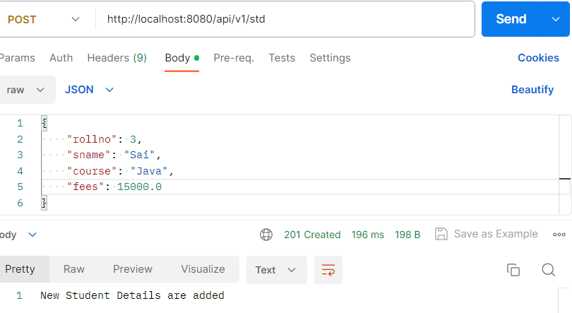**Output:**

